**Quarterly Narrative Report (QNR)**

# **1. Project Details**

GUIDELINES: Please complete the following table with details of the project.

|  |  |
| --- | --- |
| Project Number | 4257-MYP |
| Project Title | Strengthening Ear and Hearing Care Services in Ethiopia |
| City/ Country/ Region | Addis Ababa, Ethiopia, East Africa |
|  |  |
| Name of Contractual Partner | St. Paul’s Hospital Millennium Medical College (SPHMMC) |
| Other Implementing Partners | No |
|  |  |
| Duration of Project | Three years (2022-2024) |
| Project Start Date | 01.01.2022 |
| Project End Date | 3.12.2024 |
| Project Cycle | January- December |
|  |  |
| Report Submitted by; |  |
| Name | Netsanet Tekalign, Dr Alene Meshesha |
| Designation | Netsanet Tekalign-Administration/program Assistant  Alene Meshesha, MD, Assistant.Prof.ORL-HNS,SPHMMC ,  EHC Project Coordinator & Ethiopian Hearing Health Advocate. |
| Email Address | [ntekalign@sphmmc.edu.et](mailto:ntekalign@sphmmc.edu.et), [alenemeshesha@yahoo.com](mailto:alenemeshesha@yahoo.com) |
| Date of Submission | October 17,2022 |

# **2. Summary of Results Achievements**

GUIDELINES: Insert a qualitative ‘summary’ of the overall progress of the project towards its Result areas. Please focus on the changes (intentional or unintentional) that have come about as a result of implementation of activities. Limit your response to 1 paragraph per result area.

In 2022, CBM and SPHMMC signed a new 3 years’ continuation of the multiyear project plan (MYP). The project agreement was signed between CBM international and SPHMMC officials. This multi-year project will be implemented during 2022 - 2024. The project is mainly focusing on bringing changes in five result areas with key project deliverables as they are expressed in the set indicators in each result area. This 3 months report had the following major result areas to be accomplished: 1. service provision, 2. capacity building system, 3. health education & promotion 4. system, mainstreaming EHC through partnership with FMoH and other key government stakeholders, and, 5. efficient and effective project management.

Accordingly, we did most of the 1st, 2nd and 3rd quarter activities that can help the project get going and succeed .They contributed a lot towards achievement of the specific objectives of the project. Details of 2022 third quarter activities implementation are summarized here below.

**Result Area 1;**

**High quality EHC service is provided to the target population nationally**

During the 3rd quarter, like the past two quarters the project continued doing Screening services for the possible ear conditions, surgical campaigns at St Paul’s and Butajira hospitals, audiometry screening campaigns at St. Paul's hospital, outreach screening campaigns at Health centers in Addis Ababa and Oromia Liyu Zone on Ear and Hearing conditions. Through the outreach campaigns, we managed to reach out to additional beneficiaries of EHC services in the targeted communities. We were able to achieve our target under this result area in this quarter too. Hence, in terms of screening of persons with ear problems among people of all age groups were conducted for a total of 1190(females 609) .Regarding Audiology testing, a total of 869 clients (females=450) were tested, while a total of 414(243 female) people were screened during our outreach campaigns. Surgery was performed for 196 patients (females=110). We have also dispensed assistive hearing devices for 12(females=5) patients. However, we could not manage to achieve the targeted plan for this quarter. Only 50 patients were given services in this quarter for hearing aid provision because of shortage of equipment due to the delay in international procurement. Accessibility Audit is done for the ENT section of the college for the 1st time.

**Result Area 2;**

**Capacity building system will be established by providing training for Ear and Hearing Care (EHC) to Health Personnel.**

According to the plan for this quarter, we gave training to Health Care Workers(HCWs) from different departments in our College from different departments and from selected health facilities in Addis Ababa, Amhara, Oromia and Southern Nation and Nationalities People region(SNNPR). To this end, a total of 45 HCWS which includes general practitioners, health officers and nurses (out of which 26 females) have received a 3-day training on Basic Primary Ear and Hearing Care. Additionally, 2 rounds of DiD, Safeguarding and Gender mainstreaming training was done. Participants were from Higher officials from Regional health Bureaus, Health facilities from our project implementation areas and from our college. A total of 46 participants (14= females) were trained.

**Result Area 3; Health education & promotion system on EHC strengthened**

During the last 3 months, we organized a half-day awareness raising workshop in collaboration with Ethiopian National Association of the Deaf blind (ENADB). In this event, 40 participants were present including staff and board members of ENADB, OPDs, Members of ENADB, NGO representatives, Government officials, and volunteers. During the event, a briefing on awareness creation program on cause & challenges of Visual and Hearing impairment was presented by an invited Specialist Doctor and two ENADB members conducted their life experience (testimony).

WHO’s Ear and Hearing Care Guidelines with Amharic and Afan Oromo versions were distributed during the training and outreach programs.

**Result Area 4; EHC mainstreamed through partnership with the Federal Ministry of Health of Ethiopia**

**Result Area 5; Efficient and effective program management is achieved**

Managerial support, salary top ups, and related admin expenses were effected duly in each month to help facilitate implementation of planned activities’ in the last 3 months.

# **3. Narrative Reporting on Activity Implementation**

3.1 GUIDELINES: Which activities were planned to be implemented in quarter three (Q3)? Please list down the Activity Name and Number only.

**Result Area 1;**

**High quality EHC service is provided to the target population Nationally Implementation of 4 screening outreach (Nationally).**

01.02 Implementation of 4 screening outreach nationally

01.03 Perform facility based auditory function screening testing (Neonates/Children/Adults).

01.04 Clinical screening of persons with ear conditions /hearing loss or suppurative otitis media (Neonates/School Children/Adults).

01.05 Provision of assistive devices (hearing instruments and accessories) to 200 patients annually

01.06. Perform 300 ear microsurgeries at SPHMMC and Butajira annually.

01.08 Conduct accessibility Audit to make the ENT Department more accessible

01.09 Conduct Population based hearing impairment prevalence survey

**Result Area 2;**

**Capacity building system will be established by providing training for Ear and Hearing Care (EHC) to Health Personnel.**

02.02 Provision of Online Pediatrics Audiology course for 1 ENT surgeon/ENT resident/Nurse

02.03 Provision of Basic Audiology online course for 2ENT surgeons/\nurses/Residents

02.05 Conduct BPEHC training for 20 CBR workers/urban health extension workers/ other health workers

02.06 Comprehensive security and safeguarding activities.

02.07 Training of 20HCWs from SPHMMC on BPEHC

**Result Area 3; Health education & promotion system on EHC strengthened**

03.01 Awareness raising campaigns on the importance and usefulness of EHC to stakeholders (FMoH, PDO, Pediatric and Obstetrics Societies)

03.02 Four rounds of health education training/ awareness for 100 CBR and urban health extension workers from Butajira, Fiche and selected health centers in Addis Ababa annually.

03.03 Production and distribution of IEC/BCC materials on EHC services for the community annually

03.04 Standing billboards about EHC in 20 major cities

**Result Area 4; EHC mainstreamed through partnership with the Federal Ministry Health of Ethiopia.**

04.01 Printing and distribution 1000 WHO Guideline for primary/ intermediate level professionals to contribute to the incorporation of EHC training to the pre service training of health extension workers annually

04.04 EHC/ENT related training modules /materials preparation

04.05 support the FMoH/SPHMMC through arrangement of consultative meetings annually

04.06 Strengthen ENT department of SPHMMC through arrangement of consultative meetings of different academic documents development annually.

04.07 Share, develop and demonstrate the CBM concept of EHC comprehensive program, through interaction and coordination of health activities for EHC with community and education collaborators find other stakeholders annually

04.08 Monitoring and evaluation activities at national level

**Result Area 5; Efficient and effective program management is achieved**

05.01 Support proper management (Salary top-up of project director/coordinator)

05.02 Support to administrative costs for project implementation (Salary top-up of finance and admin and program assistant)

05.03 Furniture and other office materials purchase

05.04 Other related Admin expenses; travel, internet, etc.

3.2 GUIDELINES: Using the list above, please report on the activities implemented during the quarter. Describe if any targets were achieved, or explain any variance in achieved versus planned activities in the quarter. Explain who the main beneficiaries were.

**01.02 Implementation of 4 screening Outreach Nationally**

Our annual plan for this activity was to conduct four rounds of outreach campaigns, which means we were required to undergo one screening campaign in each quarter. During this quarter, we have managed to do one round of outreach programs for 5days. The campaign was done at Sebeta HC( 2days) and Alem bank HC (3days) found in Oromia Liyu zone and Addis Ababa respectively. Thus, we have achieved the quarter’s target plan. During this campaign, 414 clients (131 males, 208 females, 40 boys, 35 girls) were screened and treated during those campaigns. About 32% of the screened patients needed referral to St Paul’s for further workup and management. Additionally, IEC/BCC materials (Amharic and Oromifa versions of Posters and WHO primary Hearing Care Guidelines) were distributed to the Health facilities during this outreach program. On the other hand, health education and awareness raising activities were delivered to 818 persons during the campaign. ENT residents and Seniors ENT faculties led the health education programs from SPHMMC.

**01.03 Perform facility based auditory function screening testing (Neonates/ Children/ Adults).**

This is an all –year- long activity of the project. In the 3rd quarter,a total of 869 clients(Women 293, Girls 157, Males 229 and boys 190) were screened for their hearing status through one screening campaigns arranged at St Paul’s hospital and routine screening activities, thus we already passed the quarter target (325 clients/quarter). For all the past 9 months we managed to screened 3006 clients which is above the targeted number (1300) in the year. This number is increased due to the outreach campaign referral cases and arrangement of the Audiometry screening campaign in St paul’s Hospital. The main purpose of doing this auditory function screening testing is to know the exact number of patients who need hearing aids, microsurgeries or other related treatments according to the findings of the screening.

**01.04 Clinical screening of persons with ear conditions /hearing loss or suppurative otitis media (Neonates/School Children/Adults).**

In the 3rd quarter , clinical screening of patients with ear problems complaints was done at St. Paul’s, Butajira –‘Grarbet Tehadiso Mahber’–GTM primary hospital, Sebeta HC and Alem Bank Health Center. 1,604 patients were screened in this quarter(target was 1,250) in the above-mentioned 4 health facilities. At SPHMMC alone, 1102 patients (393 males, 463 females, Boys 147 and Girls - 99) were screened. Eighty-Eight patients (26 females, 27 males, 21 Girls, 14 Boys) were screened, consulted and assessed for possible ear surgery and other ENT related problems at GTM during this quarter. Furthermore, 414 clients (131 males, 208 females, 40 boys, 35 girls) were screened during the quarter’s outreach program at Alembank and Sebeta HCs The major findings during screening were acute otitis media, chronic suppurative otitis media, Sensorineural Hearing loss, Conductive Hearing loss and mixed hearing loss.

In total for the last 9months, a total number of 9,414 patients screened for possible ear conditions has already surpassed our annual plan of screening 5,000 patients.

**01.05 Provision of assistive devices (hearing instruments and accessories) to 200 persons annually**

A total of 14 hearing aids(out of the 50 planned for 3months) )has been fitted to 12 patients (5 hearing aids on 4 males, 3 hearing aids on 3 females, 4 hearing aids on 3 boys and 2 hearing aids on 2 girls) who qualified for device prescription. We couldn’t hit the 9 months target of fitting 150 hearing aids due to the delay in the international procurement.

Generally, provision of these devices not only helped to improve hearing conditions of the patients, but also has been contributing towards improving their communications and social interactions. This eventually will improve their overall quality of life through relieving their stress and embarrassment because such people are usually sympathized due to their hearing condition.

**01.06 Perform 300 ear microsurgeries at SPHMMC and Butajira annually.**

Performing micro ear surgeries is a very important EHC activity which should go hand in hand with clinical screening and audiometry testing. In this quarter, micro ear surgeries were done for eligible surgical candidates of St. Paul’s hospital and GRARBET Hospital. A total of 195 patients (67 males , 84 females, boys 20 and girls 24) got the required surgical procedures. The major ear conditions which led them to micro-ear surgeries were chronic suppurative otitis media with conductive hearing loss and cholesteatoma. The majority of the ear surgeries performed were tympanoplasty and mastoidectomies. We have already surpassed this quarter and for 9months planned micro ear surgeries. Additionally, the residents were given an opportunity to get hands-on training at the detachment site, Butajira GTM Hospital which definitely helped them to further develop their skills.

**01.08 Conduct accessibility Audit to make the ENT Department more accessible**

This activity was planned to be implemented in the 2nd quarter. The project had a difficult time getting this activity done during the previous years due to unavailability of appropriate experts in the field. Now, we have got a professional from the Ethiopian Center for Disability and Development (ECDD). The expert did the accessibility Audit for the ENT section of the College and other parts of the college which the ENT clients might visit like Laboratory Radiology and Pharmacy. The major findings are lack of signage to the department and to other service areas in the hospital, the OPDs and Toilets are not accessible for wheelchair users and no proper lighting of the OPD and toilets for clients who have partial vision impairment. Therefore, based on the findings, pertinent recommendations were forwarded. Presentation of findings was made for project and responsible bodies in the college about the finding and way forward. The college agreed to work to improve the accessibility of the ENT department based on the recommendations.

**01.09 Conduct Population based hearing impairment prevalence survey**

Population based hearing impairment prevalence survey was planned to be done in this year of the project. Till now, the proposal was reviewed by internal and external reviewers; a review workshop was conducted successfully. We have also received ethical approval from our college’s Institutional Review Board (IRB). In this quarter we managed to get procurement of survey materials like stationeries, 4 laptops, and 8 Audiometers. The remaining items procurement is still in process on local and international markets. Delay of international procurement is still a potential challenge to undergo the survey as initially planned. Additionally, we managed to get 7 tablet computers on loan bases for the data collection process.

**Result Area 2;**

**Capacity building system will be established by providing training for Ear and Hearing Care (EHC) to Health Personnel.**

**02.02 Provision of Online Pediatrics Audiology course for 1 ENT surgeon/ENT resident/Nurse**

For this activity, the ENT department of SPHMMC has recruited one ENT surgeon for an online pediatrics Audiology course. Additionally, an agreement with EDUPLEX institute was finalized and payment was transferred by CBM to EDUPLEX institute. Now, registration is finalized and the trainee will soon start the online sessions.

**02.03 Provision of Basic Audiology online course for 2ENT surgeons/\nurses/Residents**

Under this activity, the ENT department of SPHMMC has recruited one ENT Resident and one ENT nurse for an online basic Audiology course. Additionally, an agreement with EDUPLEX institute was finalized and payment was transferred by CBM to EDUPLEX institute. Now, registration is finalized and the trainee will soon start the online sessions.

**02.05 Conduct BPEHC training for 20 CBR workers/urban health extension workers/ other health workers**

Of the activities planned through this project in this quarter, providing ‘Basic Primary Ear and hearing care training (PEHC) for healthcare professionals who are involved in EHC service delivery is one of them. This basic PEHC training was conducted for 3 days at Embilta Hotel, Addis Ababa for healthcare professionals who come from different health institutions(Hospitals and Health Centers from Addis Ababa, Oromia, Amhara and SNNP starting from Sept 28 - 30, 2022.

Out of 25 invited participants, 24 participants (female 13) attended this training. These professionals are working at OPD, Emergency, triage in their respective institutions. Thus, they have frequent contacts with patients who are coming to their units for different health issues and they have a chance to examine patients with ear and Hearing problems. However, at the same time they don’t have the detailed knowledge and skill about many of the basic EHC related conditions. Therefore, delivering this training to the right target is very valuable and effective in order to reach those patients who need medical attention in these specific areas and need proper referrals .

The training was delivered by SPHMMC 2 ENT senior residents and it was moderated and couched by 2 ENT senior specialists from the Department. Basic and Very important topics were included in this training and according to the participants they are satisfied with the topics. To deliver this training, the methodology used were theoretical, visual through video and Discussion in a bilateral way. It was participatory and the participants were able to see the significance of some cases.

**02.06 Comprehensive security and safeguarding activities.**

In this quarter we managed to deliver 2 rounds of training to our stakeholders on Disability inclusive developments, Safeguarding and Gender mainstreaming training. The 1st round was conducted from August 03 - 05, 2022 and 2nd round was conducted from September 22- 24, 2022, at Embilta Hotel, Addis Ababa. In the two rounds a total of 51 participants were invited and 46 (females 14) participants attended the training. The participants were from Regional Health Bureaus and Health institutions who are in the program leadership positions in their respective offices. Since the trainees are in a position to change malpractice related to this issue, delivering this awareness raising training to the higher officials, believed to be effective and efficient in improving the problems related to DiD, Safeguarding and Gender mainstreaming. The participants expressed that the training helped them to get awareness in these three basic areas and created an opportunity to see their organization's strengths and weaknesses.

The training was delivered by one trained staff from SPHMMC by CBM, 2 trainers from Ethiopian Center for Disability Development(ECDD) and 2 trainers from Ethiopian Women With Disabilities National Association(EWDNA).

**02.07 Training of 20HCWs from SPHMMC on BPEHC**

This basic PEHC training is conducted for 3 days at Embilta Hotel, Addis Ababa for health care professionals who work in different departments of our college starting from Sept 19 - 21, 2022. Out of 23 invited participants, 21(14 females) participants attended this training. These professionals are working at OPD, Emergency, triage and ward in their respective departments. Thus, they have frequent contacts with patients who are coming to their units for different health issues and they have a chance to examine patients with ear and Hearing problems. However, at the same time they don’t have the detailed knowledge and skill about many of the basic EHC related conditions. Therefore, delivering this training to the right target is very valuable and effective in order to reach those patients who need medical attention in these specific areas and need proper referrals .

The training was delivered by SPHMMC 2 ENT senior residents and it was moderated and couched by 1 ENT senior specialists from the Department. Basic and Very important topics were included in this training and according to the participants they are satisfied with the topic.

**Result Area 3;**

**Health education & promotion system on EHC strengthened**

**03.01 Awareness raising campaigns on the importance and usefulness of EHC to stakeholders (FMoH, PDO, Pediatric and Obstetrics Societies annually)**

In the previous quarter, we communicated with Organizations for Persons with Disabilities (ODPs), Society for Deaf and Blind and Ethiopian Women with Disabilities National Association. The Society for Deaf and Blind already organized the awareness raising event. In this event 40 participants were present including staff and board members of ENADB, OPDs, Members of ENADB, NGO representatives, Government officials, and volunteers. During the event, a Briefing on Awareness creation program on cause & challenges of Visual and Hearing impairment was presented by an invited Specialist Doctor and two ENADB members conducted their life experience (testimony).

The other DPO we contacted for the awareness raising workshop is Ethiopian Women with Disabilities National Association(EWDNA), they promised to deliver the awareness raising event in the near future and will send a report sooner.

**03.02 Four rounds of health education training/ awareness for 100 CBR and urban health extension workers from Butajira, Fiche and selected health centers in Addis Ababa annually.**

Awareness creation activities were integrated with our outreach campaign programs on activity 01.02 for effective implementation, accordingly, the project has managed to reach out to around 818 persons during our outreach program in this quarter. Health Education was given during the campaign programs for clients available in the visited health facilities. The Health education was on basic ear Care with special emphasis on caring for draining ears and avoiding unnecessary ear picking.

**03.03 Production and distribution of IEC/BCC materials on EHC services for the community annually**

In the previous quarters WHO’s Ear and Hearing Care Guidelines with Amharic and Afan Oromo versions were also printed and started distributed. In this quarter distribution of the remaining WHO EHC Guideline and other IEC/BCC posters has continued through training and outreach programs held over the 3rd quarter.

**03.04 Standing billboards about EHC in 20 major cities**

Procurement process has been started, but we couldn't manage to do the procurement of all 20 standing billboards due to current price inflation in the country. Thus, we were obligated to down size the number to six. Currently, we selected areas to put the standing billboards in Addis Ababa and we started processing to get permission in the specific offices to do so.

**Result Area 4; EHC mainstreamed through partnership with the Federal Ministry Health of Ethiopia.**

**04.01 Printing and distribution 1000 WHO Guideline for primary/ intermediate level professionals to contribute to the incorporation of EHC training to the pre- service training of health extension workers annually**

We have prepared to order printing of more WHO guidelines in all the three languages (Amharic, English and Oromifa) and additional IEC/BCC posters/ flyers .

**04.02 Strengthen National ENT-EHC TWG through facilitation of 3cnsultative meeting annually**

Until this quarter, this activity was not implemented due to the non response from the MoH side

**04.03 Strengthen Ethiopian Society of Otolaryngology-HNS professionals through financing annual conference**

The society hasn’t renewed its license and we are planning to repurpose the budget to another activity.

04.04. No new developments, so we request reallocation to activity no 02.01

**04.05 Support the FMoH/SPHMMC through arrangement of consultative meetings annually**

The college utilized the money earlier according to the plan and we will use the rest soon.

**04.06 Strengthen ENT department of SPHMMC through arrangement of consultative meetings of different academic documents development annually.**

In the previous quarter, a consultative meeting of the ENT department and document development on cadaveric dissection and document preparation was done in collaboration with the Forensic Medicine and Toxicology department. The department of Forensic Medicine and toxicology has submitted a ToR to the ENT department of SPHMMC. The zero draft document of cadaver and document preparation submitted to the ENT department. The department is working on finalizing the document.

**04.07 Share, develop and demonstrate the CBM concept of EHC comprehensive program, through interaction and coordination of health activities for EHC with community and education collaborators find other stakeholders annually**

We managed 2 Butajira Surgical campaign trips in the 3rd quarter of the year in order to demonstrate the comprehensiveness of EHC.

**04.08 Monitoring and evaluation activities at national level**

Monitoring and evaluation activity should be done in all quarters. During this quarter of the year we couldn’t implement it due to time constraints and postponed the visit to the start of the 4th quarter.

**Result Area 5; Efficient and effective program management is achieved**

**05.01 Support proper management (Salary top-up of project director/coordinator)**

In the last 3 months salary top ups were paid on a monthly basis to the project director for proper project management and follow-ups based on the project implementation plan.

**05.02 Support to administrative costs for project implementation (Salary top-up of finance and admin and program assistant)**

In the last 3 months salary top ups were paid on a monthly basis to the finance and admin/program assistant for proper project administration and financial implementation based on the project plan.

**05.03 Furniture’s and other office materials purchase**

Office furniture was purchased in the last 3 quarters, which includes 2 desktop computers, 2 printers and 2 LCD projectors for the project and ENT department Office activities. Furthermore, 4 UPS and 4 staff lockers were purchased. But procurement of office chairs is still on process

**05.04 Other related Admin expenses; travel, internet etc.**

In the last 9months internet service payments and mobile card top ups for project staff were done under this activity.

# **4. Challenges and Lessons Learned**

GUIDELINES: Please complete the table below with challenges that were encountered during the reporting period and the lessons learned. Include any solution that you plan to implement in the next reporting period. (If you have used the Status Column in the Indicator Tracking Sheet (Column K) to report Challenges against specific indicators, make sure you elaborate on the challenge in the table below)

|  |  |
| --- | --- |
| Challenge | Lessons learned / solutions |
| Time constraint to M & E Visit | postponed the visit to 4th quarter |
| Unavailability of Partners such as MoH in Major events | Trying to communicate them in each events which needs their participation |
| Delay of international procurement to start the population based survey | Sending frequent reminders |
| Short staffing and burnout of project staff | Work on substitution options |
| Price Inflation of billboard procurement of materials | down size the number |
| Increased flow of clients and surgical backlog | Optimizing screening and surgical campaigns |
| Overall political instability and security concerns | Apply security tips |

GUIDELINES: Please use the space below to specify any changes to (I) the implementation plan (strategies, timelines, targets or key results; also specify if any approval for changes has been sought from CBM), (II) any changes in personnel at the organization’s senior management level, (III) key positions related to the project implementation.

It has been recalled that we planned to post 20 billboards to 20 major cities. But due to price inflation in the country, we were forced to downsize the number to 6.

**6. Risk Update (If applicable)**

GUIDELINES: Have any of the risks identified during the project design materialized or changed?

No risk update has materialized so far

**7. Activity Forecast**

GUIDELINES: Which activities are planned to be implemented in the next 6 months (Q3 and Q4)? Please list down the Activity Name and Number only.

**Result Area 1;**

**High quality EHC service is provided to the target population Nationally Implementation of 4 screening outreach (Nationally).**

01.02 Implementation of 4 screening outreach nationally

01.03 Perform facility based auditory function screening testing (Neonates/Children/Adults).

01.04 Clinical screening of persons with ear conditions /hearing loss or suppurative otitis media (Neonates/School Children/Adults).

01.05 Provision of assistive devices (hearing instruments and accessories) to 200 patients annually

01.06. Perform 300 ear microsurgeries at SPHMMC and Butajira annually.

01.08 Conduct accessibility Audit to make the ENT Department more accessible

01.09 Conduct Population based hearing impairment prevalence survey

01.10 Establish 1 Comprehensive Otology setting at specialized hospital nationally annually

01.11 one basic ENT unit established at fiche hospital

**Result Area 2;**

**Capacity building system will be established by providing training for Ear and Hearing Care (EHC) to Health Personnel.**

02.02 Provision of Online Pediatrics Audiology course for 1 ENT surgeon/ENT resident/Nurse

02.03 Provision of Basic Audiology online course for 2ENT surgeons/\nurses/Residents

**Result Area 3; Health education & promotion system on EHC strengthened**

03.01 Awareness raising campaigns on the importance and usefulness of EHC to stakeholders (FMoH, PDO, Pediatric and Obstetrics Societies)

03.02 Four rounds of health education training/ awareness for 100 CBR and urban health extension workers from Butajira, Fiche and selected health centers in Addis Ababa annually.

03.04 Standing billboards about EHC in 20 major cities

**Result Area 4; EHC mainstreamed through partnership with the Federal Ministry Health of Ethiopia.**

04.01 Printing and distributing 1000 WHO guidelines for primary/intermediate level professionals to contribute to the incorporation of EHC training to the pre service training of health extension workers

04.05 support the FMoH/SPHMMC through arrangement of consultative meetings annually

04.06 Strengthen ENT department of SPHMMC through arrangement of consultative meetings of different academic documents development annually.

04.07 Share, develop and demonstrate the CBM concept of EHC comprehensive program, through interaction and coordination of health activities for EHC with community and education collaborators find other stakeholders annually

04.08 Monitoring and evaluation activities at national level

**Result Area 5; Efficient and effective program management is achieved**

05.01 Support proper management (Salary top-up of project director/coordinator)

05.02 Support to administrative costs for project implementation (Salary top-up of finance and admin and program assistant)

05.03 Furniture and other office materials purchase

05.04 Other related Admin expenses; travel, internet, etc.

# **8. Photos**

GUIDELINES: Please use the space below to paste any photos, with captions, news items etc. related to the project. Please ensure that written consent has been obtained from all identifiable people in the photos.

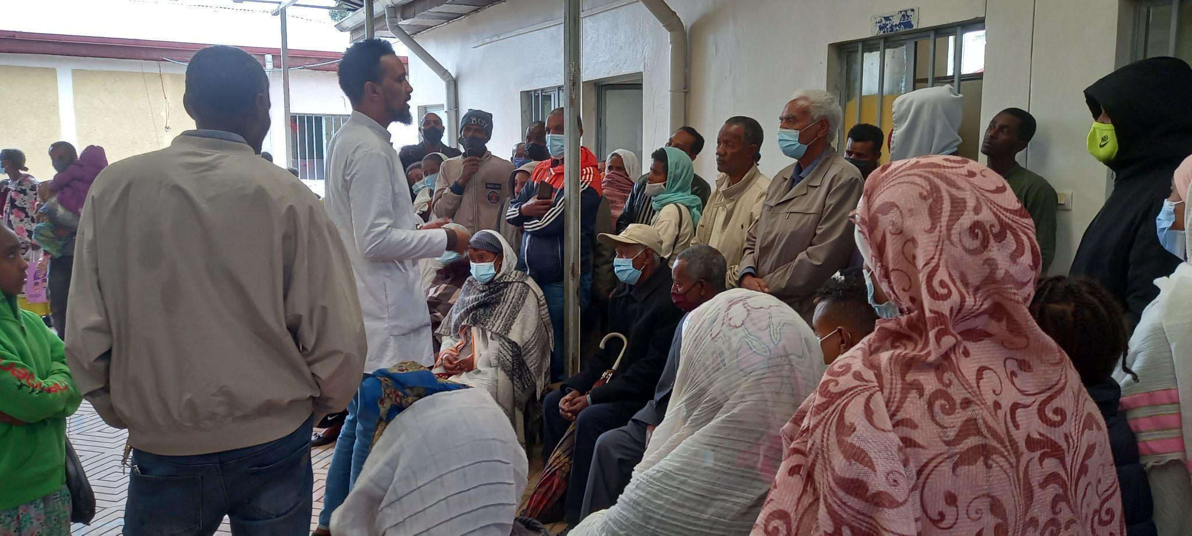

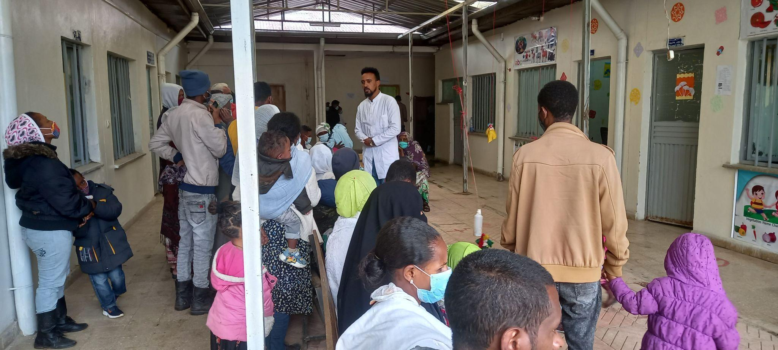

Awareness creation activity during the outreach campaign at Alem Bank HC

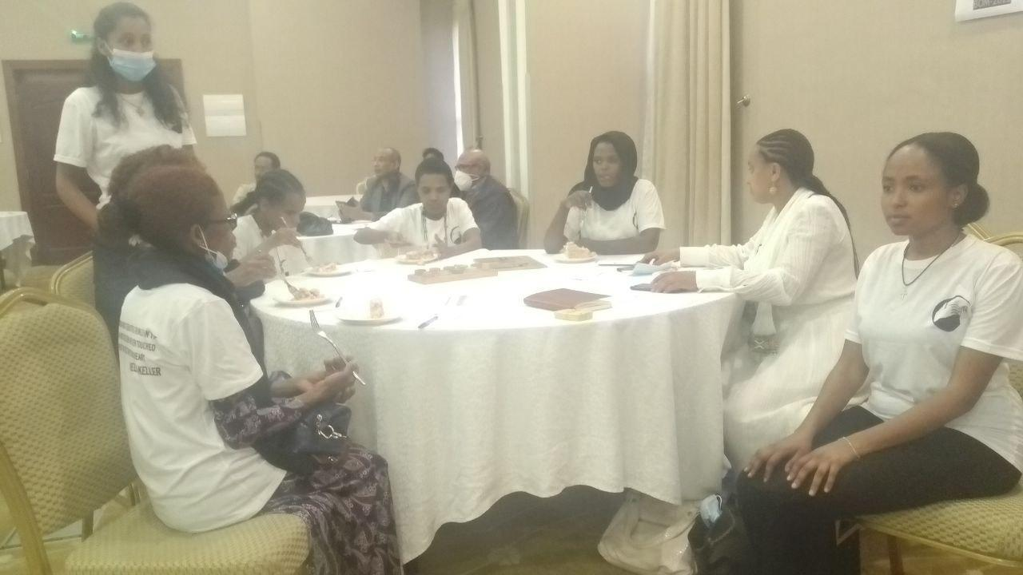

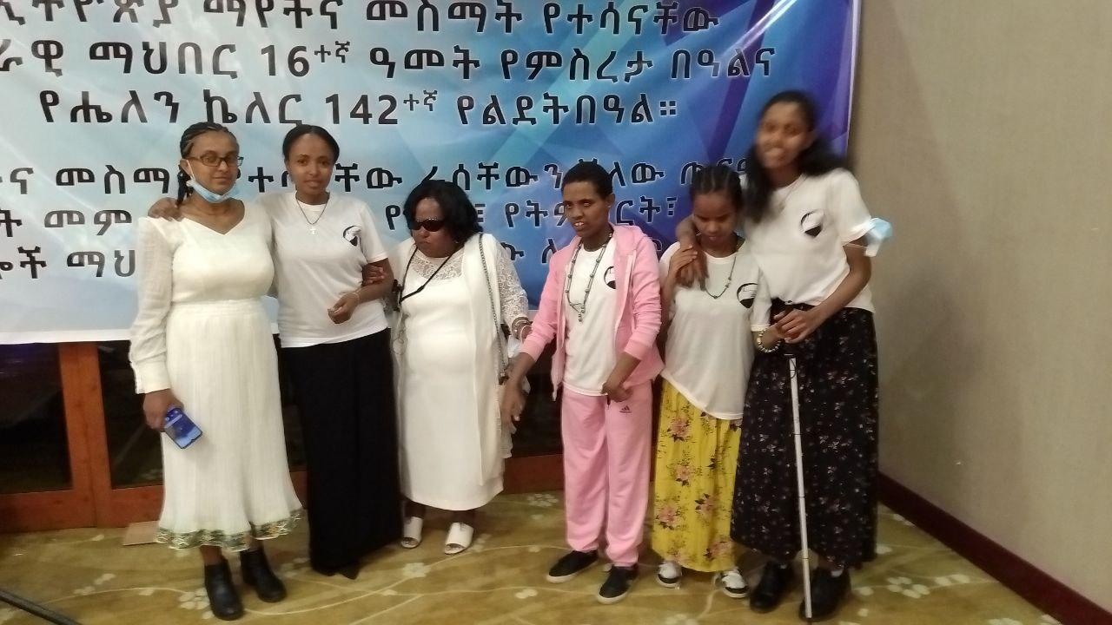

Awareness raising workshop held in collaboration with ENADB

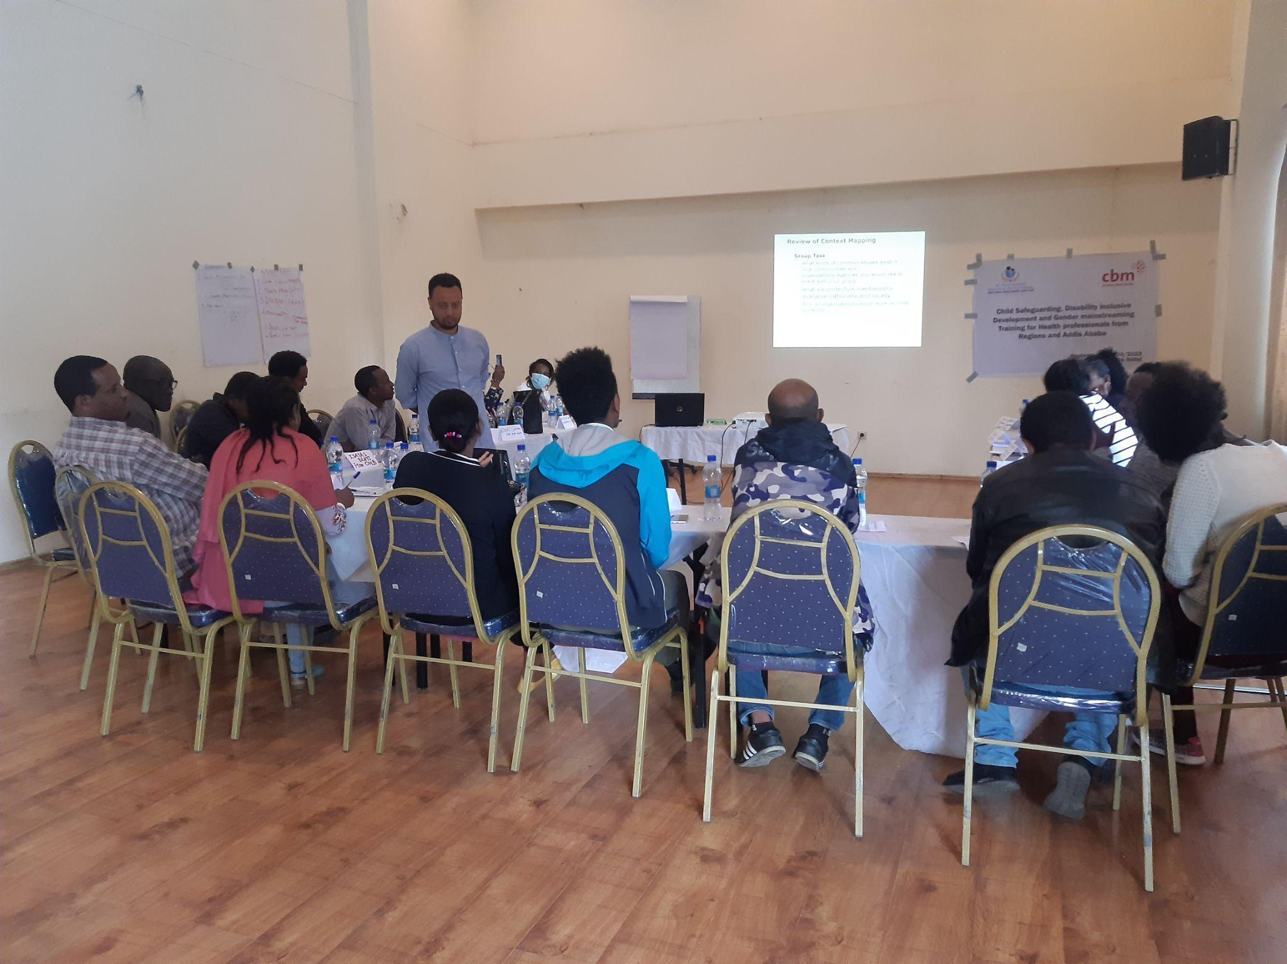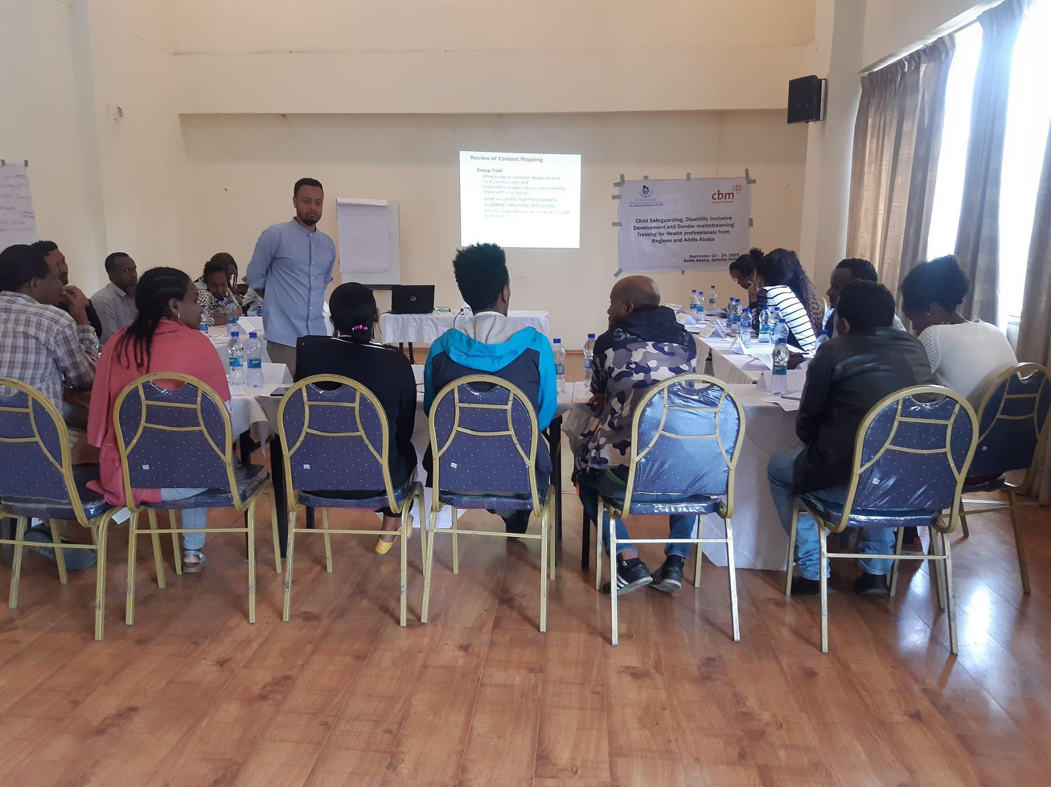

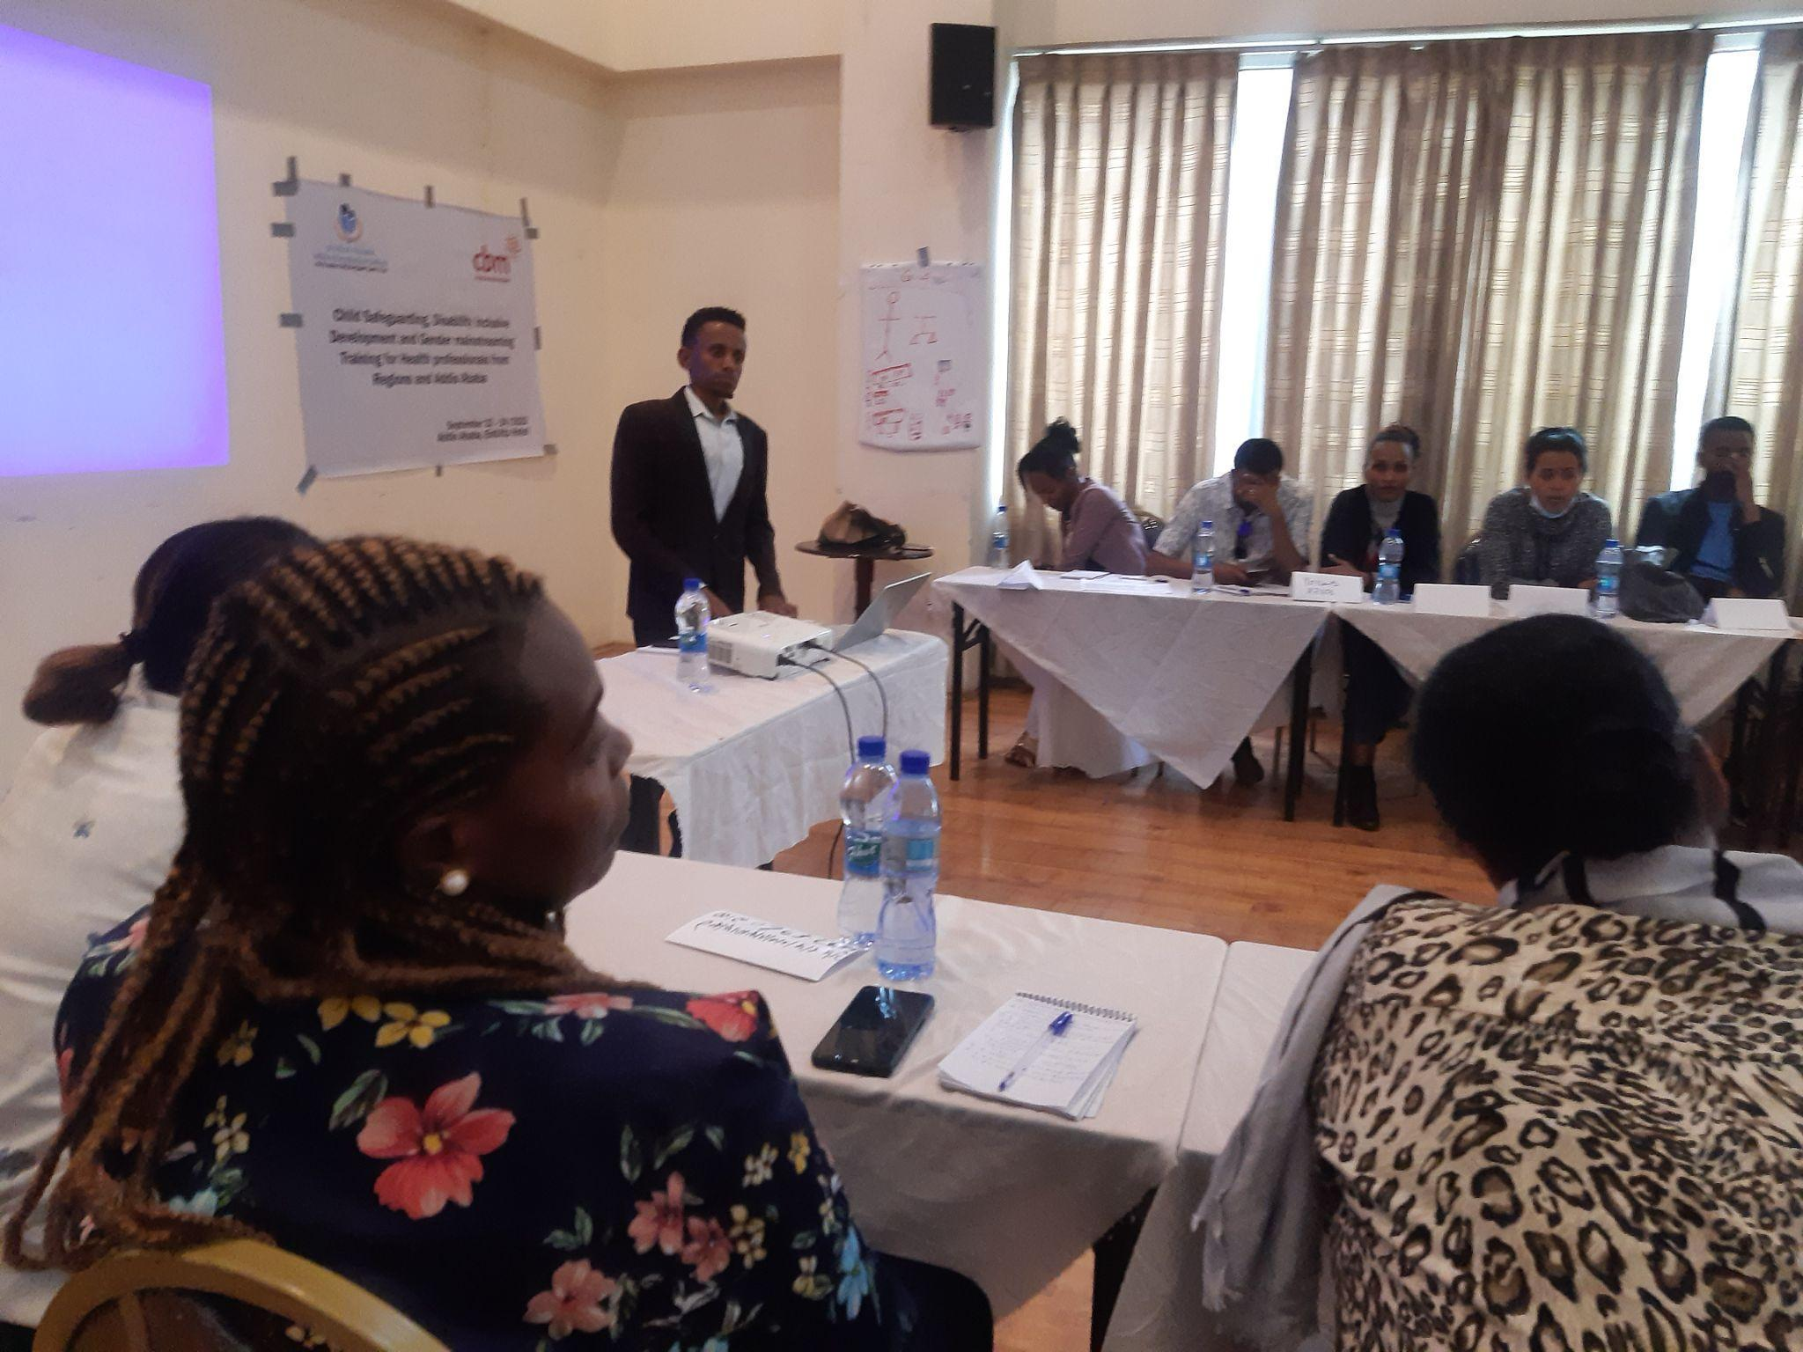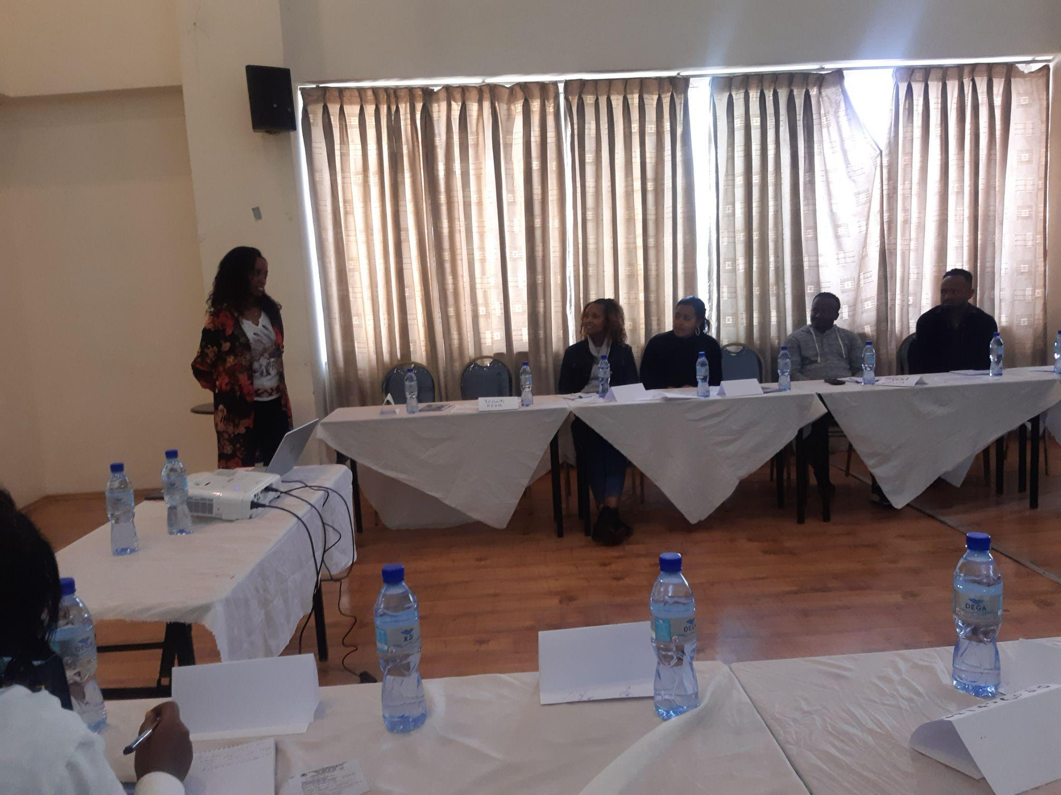

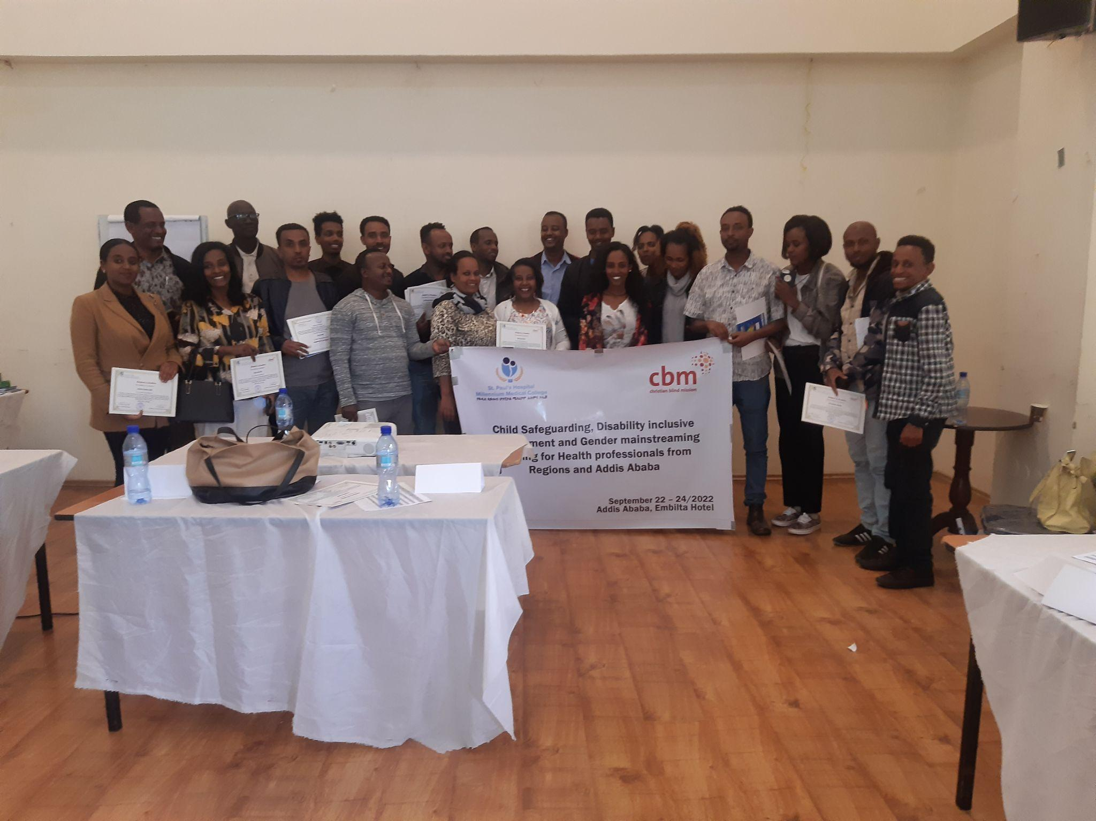

**2 rounds, DiD, Safeguarding and Gender mainstreaming training , Addis Ababa**

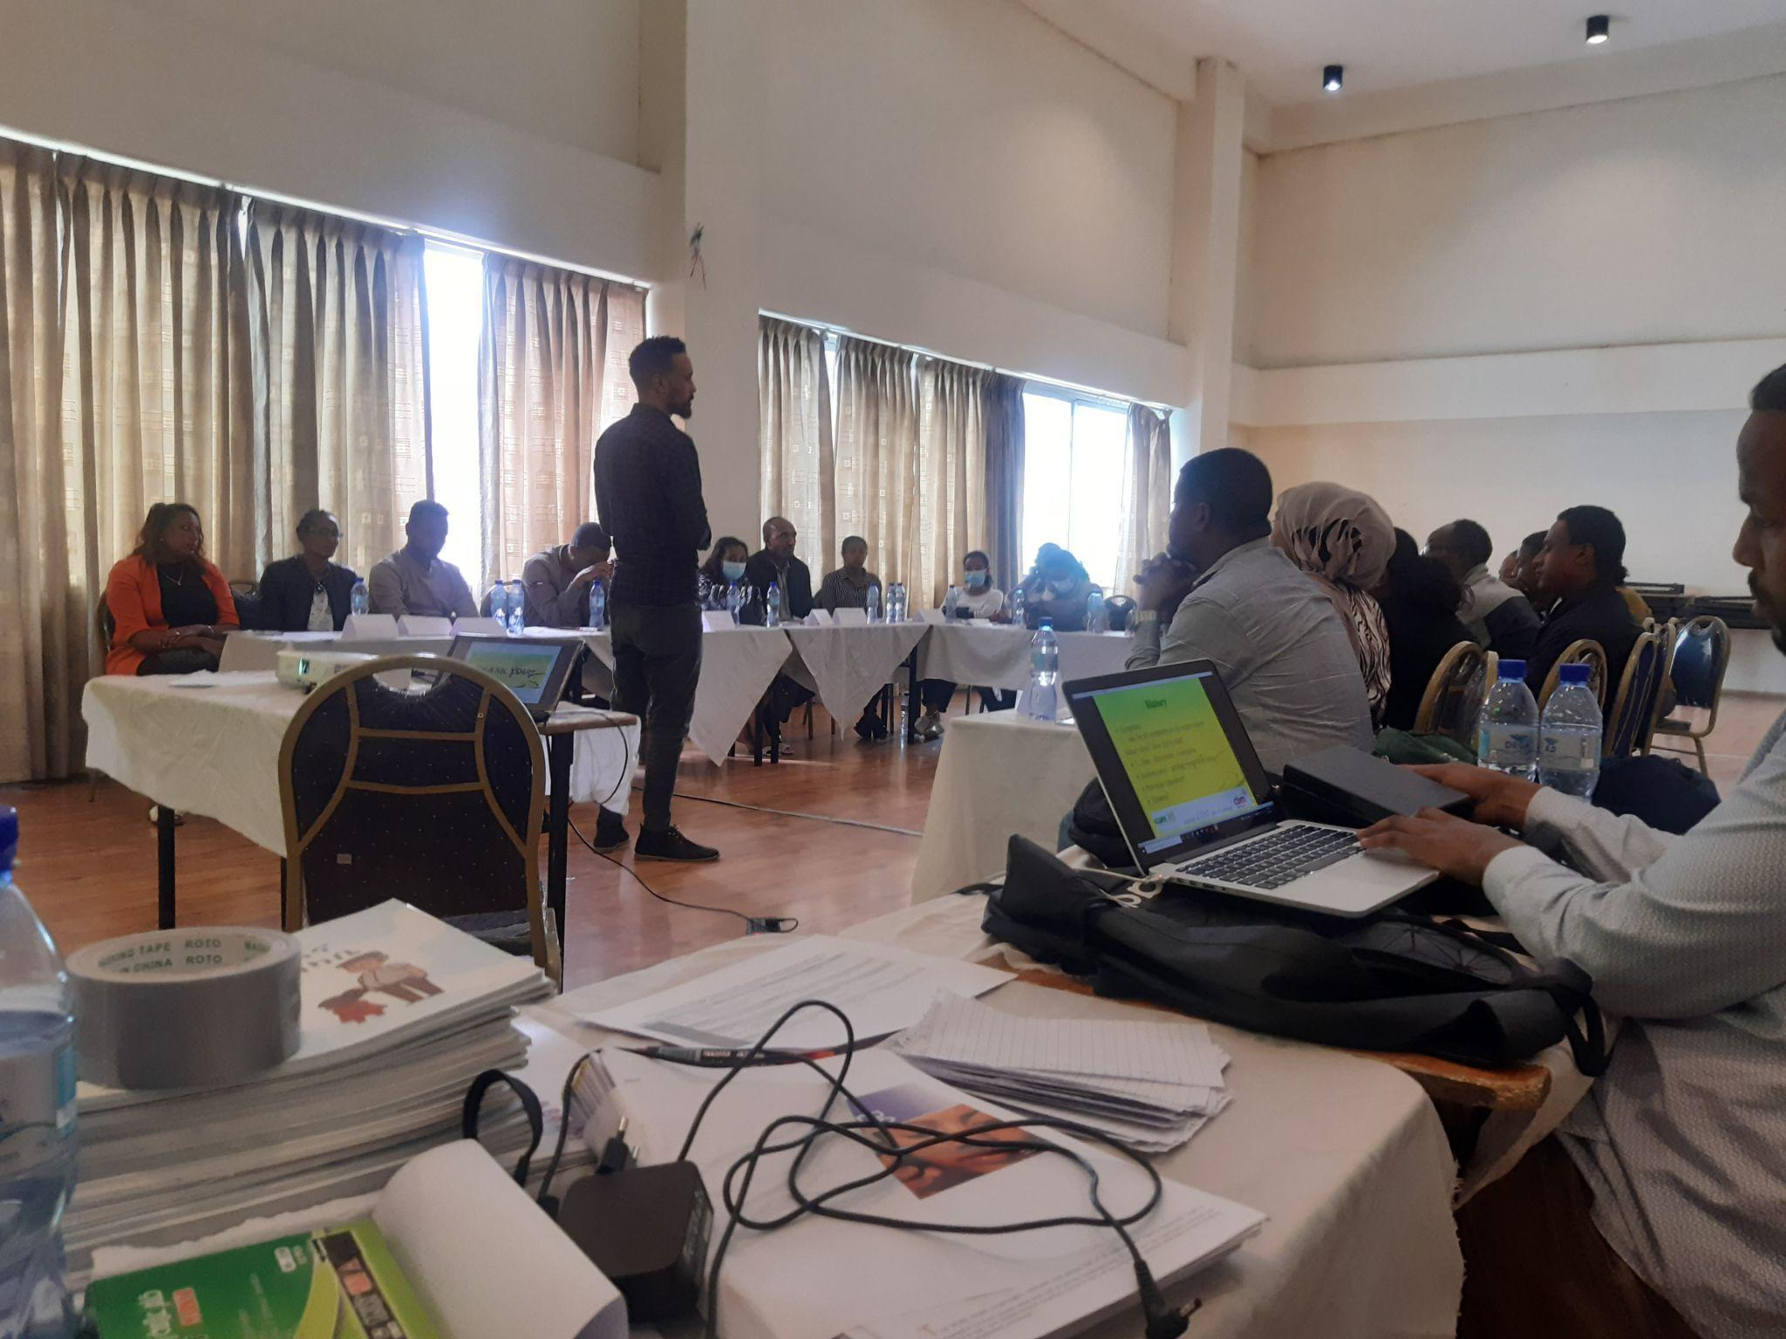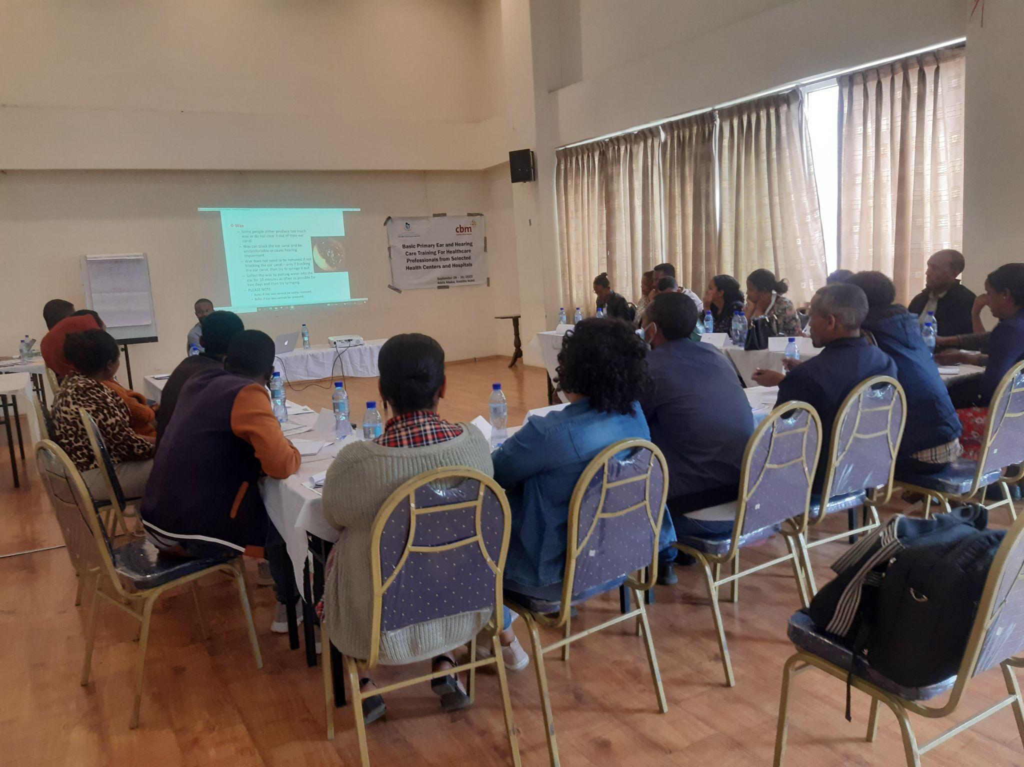

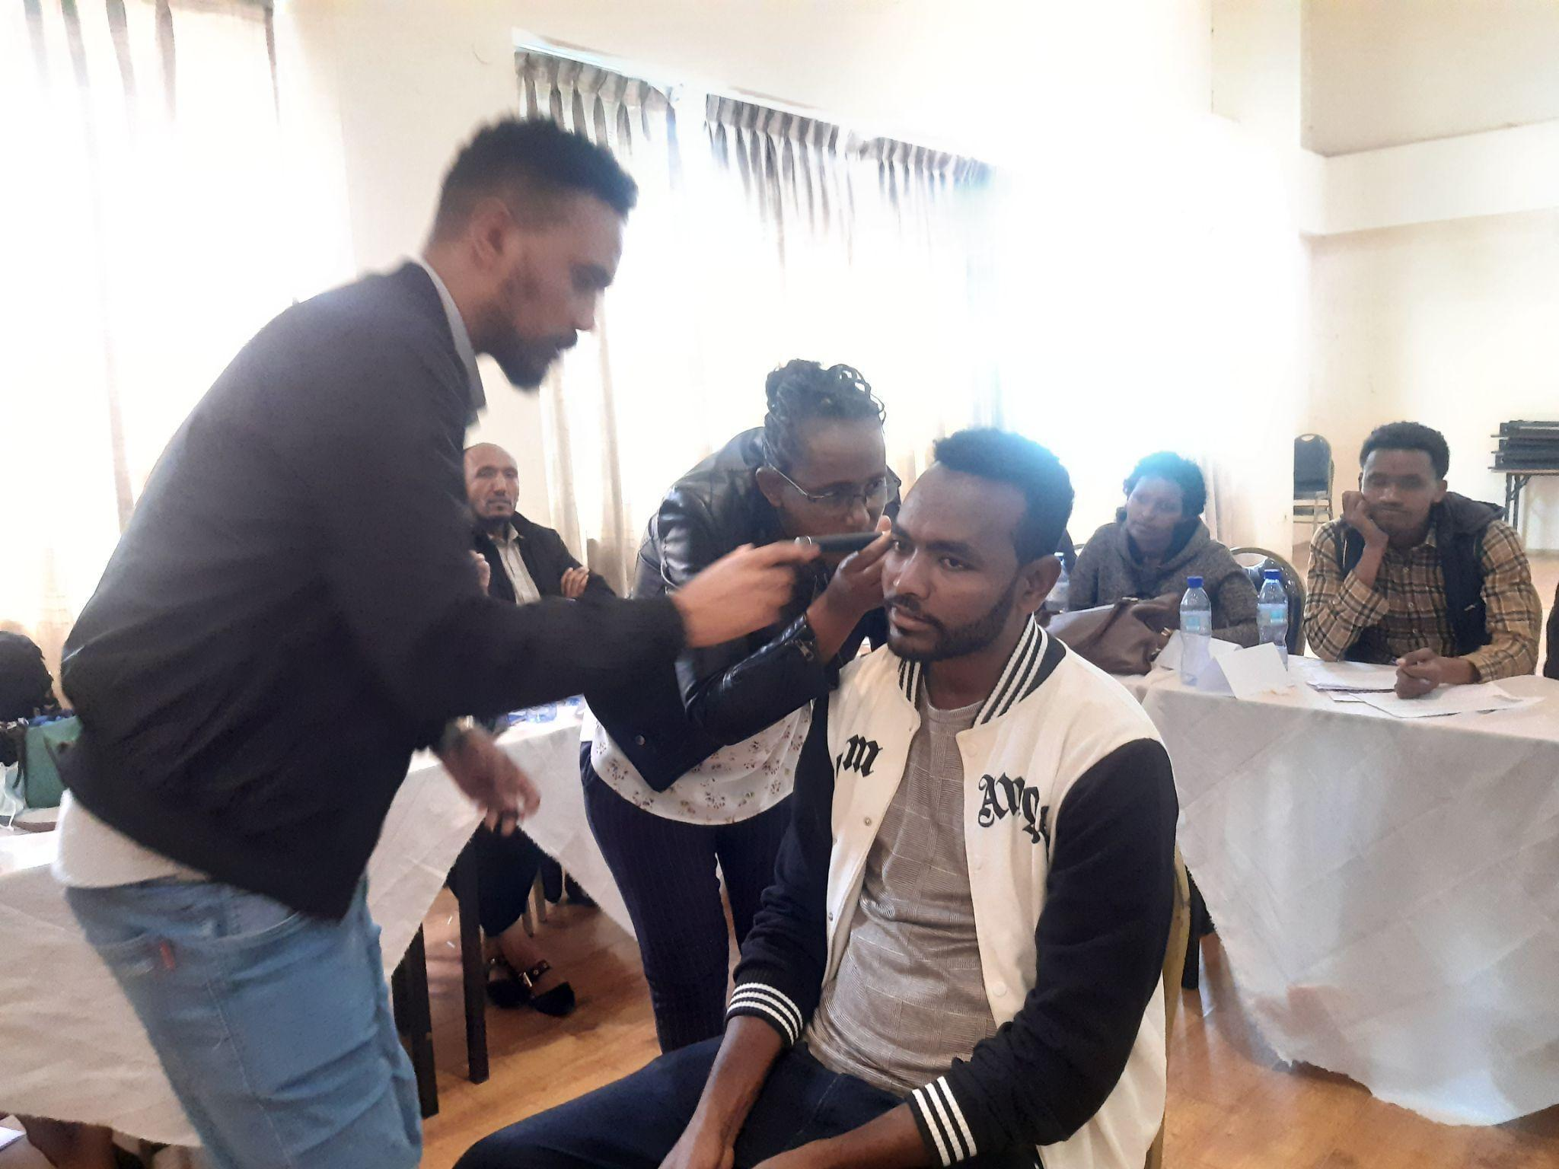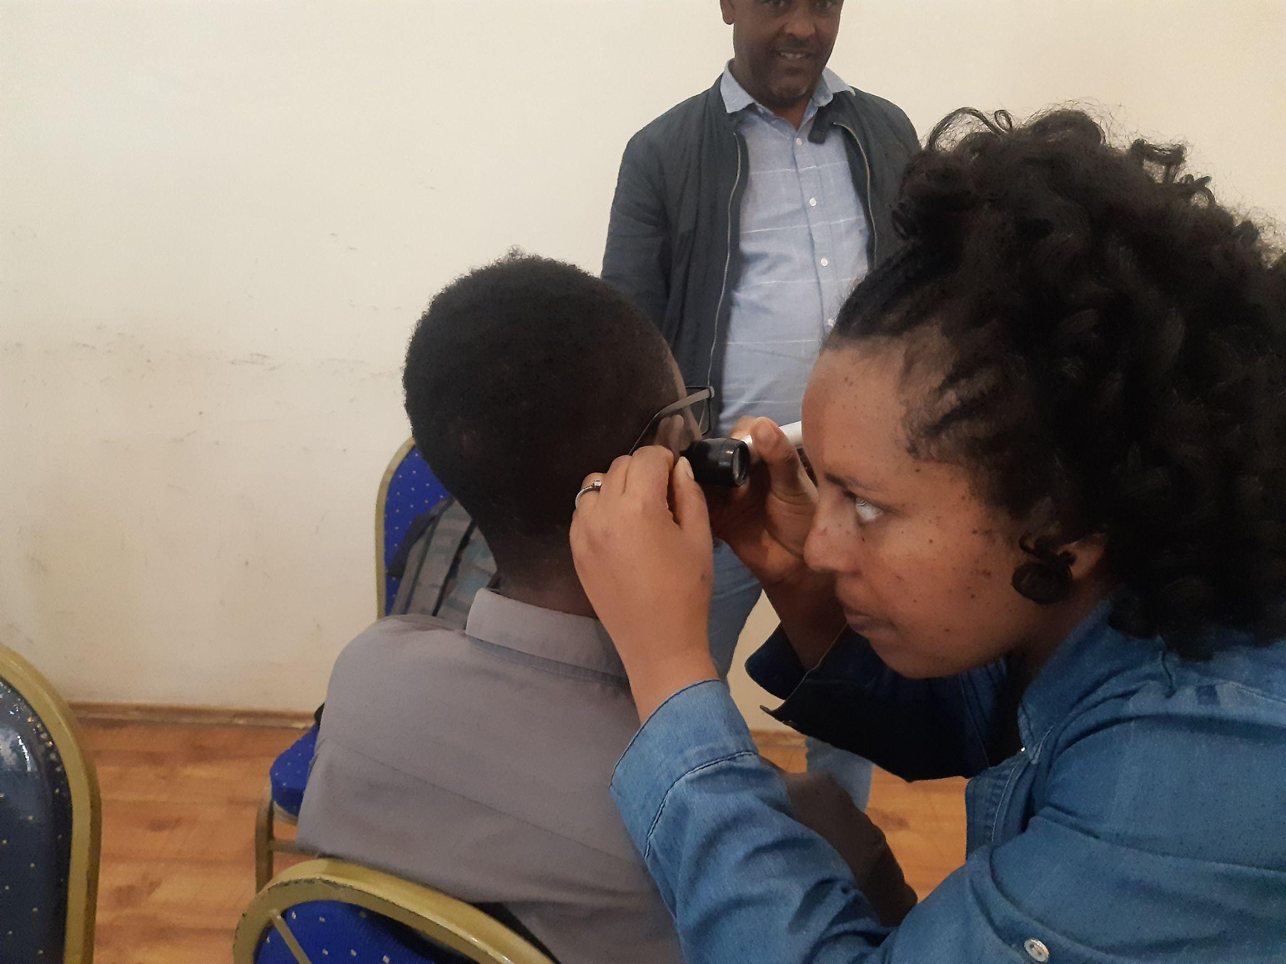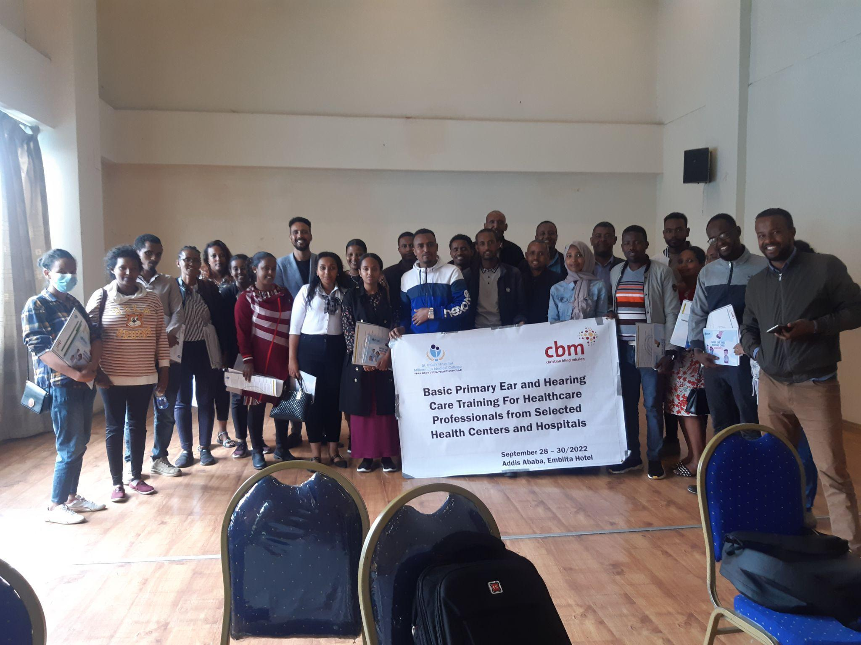

**BPEHC training for HCWs in Selected Health facilities in AA and Regions (Sept 28 -30, 2022)**

# 

# **BPEHC training for SPHMMC staffs (Sep 19 - 21, 2022)**

# **9. Comments from CBM Country Office[1]**

GUIDELINES: **(Only to be filled by the Country Office)** Please use the space below to briefly comment on the quality of project implementation and reporting, and describe whether the project is on track and on schedule. If a monitoring visit was conducted during the last 2 quarters, what were the main findings and recommendations?

The project’s planned activities are being implemented fairly as per the scope, schedule and budget, and quality. However, still some activities from result 4 : EHC mainstreamed through partnership with the FMoH- Ethiopia are still way behind the schedule or they are being challenged to be undertaken due to lack of collaboration of key stakeholders from for example FMoH and Ethiopian Society of Otolaryngology and developing the concept of comprehensive EHC through Interaction and coordination of health activities with community and dedication collaborators and other stakeholders at activity 04.07. Hence, budget of a few activities have been re-allocated for another activity. Status of targets to reach in various EHC services is in good progress where some activities have achieved more than the set targets in the log frame. One of the milestone activity with huge budget is conducting public survey on prevalence of HEC problems in the country is being challenged because of lengthy overseas procurement process even though some progress was made in developing a proposal. The proposal was well discussed with the consultants and key stakeholders and it received ethical approval from the college’s Institutional Review Board (IRB). The partner should make improvements in duly delivering periodic reports and revisions based on feedback and comments given by the CO .

1. If there is no Country Office, then the Regional Office/IAA/TU is invited to share their comments as per the arrangement.